Communications and Information Technology Communication in Saudi Arabia
Student’s Name
Institutional Affiliation
Course Name
Professor’s Name
Assignment Due Date

Saudi Arabia: Communications and Information Technology Communication
In Saudi Arabia, the communications and Information Technology Commission (CITC) main aim is to promote the information and communications sectors with a competitive competition. The work in developing new information technologies and also protects the interests of people that use telecommunications (Simsim,2011). These commissions are also responsible for internet regulation and firewall hosting which works in blocking access to different websites by thousands of people mainly because of the political and sexual content online. Saudi Arabia's internet authorities have blocked Megaupload access intermittently. Saudi Arabia's government has started an ICT national strategy level to it to a knowledge society. The industries in this country occupy information technology and telecommunications representing 51 and 55 percent.
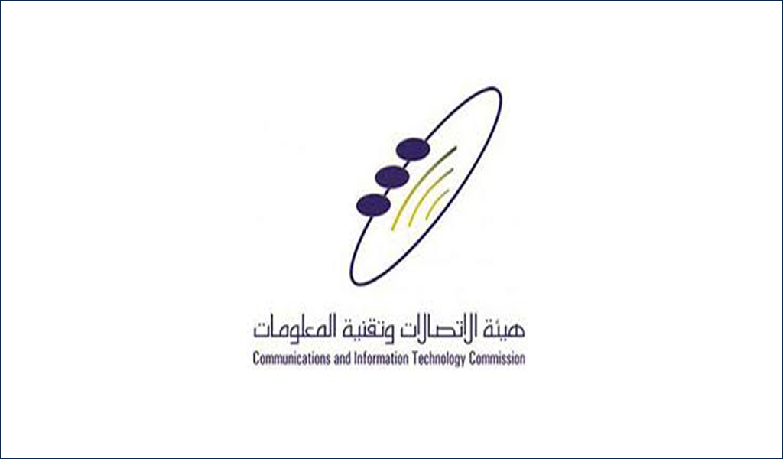
E-COMMERCE
CITC in Saudi adds more New apps to the delivery approved apps list.
They said that the main aim of this is measure is to meet the service's delivery during this period through electronic applications due to the demand increase. The number of apps brought the total to twenty. The service delivery providers were issued with directives by the CITC to take several precautionary measures in preventing coronavirus spread. Deliverymen safety was to be verified daily by temperature checkups. The commission has also emphasized the delivery of men's importance of maintaining hygiene through wearing gloves, hand sanitization and frequently changing their face masks (Alkhamisi,2013). The use of electronic payment systems, avoiding handshake and keeping a distance of two meters when delivering the orders is also advised. It is also intensifying all the service provider's inspection and supervision to make use that all these rules are followed and the right measures taken to those who do not obey. This capability according to Saudi Press Company (SPA) has allowed people to optimize all the danger whether large or small.

Foreign operators in Saudi Arabia to be granted with New Network licenses
There are plans to have its telecom sector opened to increase competition with the plans of awarding the foreign virtual operators with licenses. This is a huge plan form the Communication and Information Technolo gy Commission (CITC) to increase the sector of the ICT with a kingdom 50% increase and GPD with $13.3 billion. There will be an increase in industries’ competition such as Zain, Mobility and Telecommunication’s innovation company. MVNO Licenses have also been offered to Lebara, Etihad Jawraa and virgin by the government which will enhance this sector’s investment prospects (Meddour,2011). In Saudi Arabia, there are 43.8 million subscribers for the mobile network which of the total population penetrates at the rate of 129% using mobile phones. This country’s Information technology investment is being boosted by the tech-savy and young population with 585 of individuals under the age of thirty.
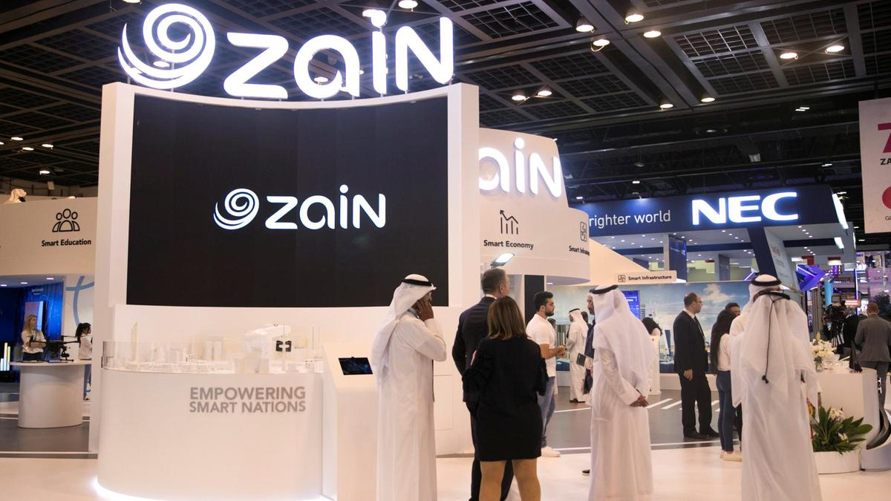
TELECOMMUNICATIONS
CITC in Saudi Arabia calls for applications to issue the foreign mobile virtual network operators with licenses.
Making such a decision will play an important role in achieving the 2030’s objective vison in Saudi Arabia to have the information technology and communication (ICT) dynamism sector through digital technologies use while developing the knowledge-based on the economy in this kingdom. According to Saudi Arabia's CITCT, MENAFN released an RFA application request to make Foreign Mobile Virtual Network (MVNO) licenses to give them a chance of investing in KSA. Modi in India calls for Communal Northeast Delhi mob ravages in brotherhood forms. Saudi Arabia was connected to telecommunications through the international Mobile Roaming by a bridge in 2013 which traditionally means that applications and issuance of Telecommunications licenses are approved with inclusive of internet access services, public radio and mobile virtual network operators.

Saudi MCIT, Nokia ink deal to set up a global software development unit
Nokia shall cooperate with Communications and Information Technology (CITC) and MCIT according to the memorandum on IoT and 5G initiatives and their usage ideas as per the standards from Nokia Company to support the kingdom to be at least with 5G and IoT technology in the MENA region (Abdelshafie,2014). Experts from Nokia will furnish advice and get engaged with the relevant stakeholders from CITC and MCIT on the future and current trends on technology and the impact they will bring on the economy, limited to but including technology updates, workshops, monetization studies, business case, and spectrum allocation.5G which is Zain's extensive roll out the first phase covers more than twenty cities in Saudi Arabia and is supported by around two thousand towers of 5G making the region's largest network. As the years go by, the network will cover more cities.
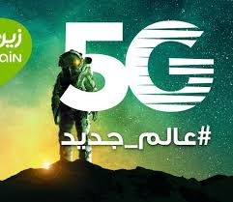
TECHNOLOGY
Saudi Arabia praised for keeping millions of people connected during Haj.
They have worked hard in making sure that people that come in are provided with enough technology. Each year, more than two million people come to Saudi Arabia to perform Hajj and a huge work amount is required to ensure reliable connectivity to all of them. They not only use their phone's data for instant and text messages but also share videos and photos taken through the Internet. The one responsible for Internet society strategy development, its infrastructure expansion, emerging economies’ capacities, and access is coffin (Qurashi,2018). Riyadh and Coffin's main intention is to create an internet connection with the help of IXP. They are working to make sure that a more level playing field is available for everyone, the internet is cheaper and faster. Their 2010 vison is to develop a health sector, business and literacy internet connectivity.


References
Abdelshafie, A. G. M. (2014). Trends and practices of e-waste management through reverse logistics-a case study: Samsung Electronics Company (Master's thesis, Høgskolen I Molde-Vitenskapelig høgskole I Logistik).
Alkhamisi, A. O., Arabia, S., & Monowar, M. M. (2013). Rise of augmented reality: Current and future application areas. International journal of internet and distributed systems, 1(04), 25.
Meddour, D. E., Rasheed, T., & Gourhant, Y. (2011). On the role of infrastructure sharing for mobile network operators in emerging markets. Computer Networks, 55(7), 1576-1591.
Qurashi, J., & Sharpley, R. A. (2018). The impact of SMART media technologies (SMT) on the spiritual experience of hajj pilgrims. International Journal of Religious Tourism and Pilgrimage, 6(3), 6.
Simsim, M. T. (2011). Internet usage and user preferences in Saudi Arabia. Journal of King Saud University-Engineering Sciences, 23(2), 101-107.

